AVIAN COMMUNITY CHARACTERISTICS AND DEMOGRAPHICS REVEAL HOW CONSERVATION VALUE OF REGENERATING TROPICAL DRY FORESTS CHANGES WITH FOREST AGE

Steven C. Latta, Danilo A. Mejia, and Maria M. Paulino

Steven Latta (Corresponding author)
National Aviary
Allegheny Commons West
Pittsburgh, Pennsylvania 1521, USA

E-mail: steven.latta@aviary.org

Tel. 412-258-9451; Fax 412-246-0490

Danilo A. Mejia and Maria M. Paulino
Grupo Acción Ecologica
La Joya, Duarte Province
Dominican Republic

ABSTRACT
Expansion of secondary forests following the abandonment of agriculture may have important implications for bird conservation, but few studies have examined the dynamics of this process. We studied bird use of differently-aged abandoned pastures regenerating to dry forest to better understand how the value of these habitats to birds changes over time. In a 5-yr study on Hispaniola, we recorded 7,315 net captures of 60 species of landbirds in study sites 2, 5, 10, and 20-yr post-abandonment, and in mature dry forest. 25 species made up 97% of all net captures. Highest capture rates were in 2-yr and 5-yr old sites. Early-successional habitats had many over-wintering Neotropical migrants; among residents, granivores and frugivores predominated. In contrast, both the 20-yr old and mature forest sites had few migrants, more resident insectivores and omnivorous species, and a greater proportion of endemics. Age and sex ratios, body condition and site persistence suggest early successional sites were sub-optimal for over-wintering migrants; results for permanent residents varied among species. Remnant trees and understory shrubs in the agroecological matrix contributed to avian diversity in regenerating dry forest sites, and proximity to mature forest also affected the diversity and abundance of birds in regenerating habitat. Our study shows that regenerating forests do not fully compensate for loss of mature dry forest habitat; natural restoration of complex microhabitats in dry forest sites converted to agriculture may take decades or longer. The highest value of regenerating forests may be their role in creating a buffer zone that enhances biodiversity conservation by re-integrating these lands into the protected tracts of mature forest needed by the islands more unique and endemic bird species.
Keywords: agroecosystems, avian abundance, buffer zones, Dominican Republic, endemics, habitat change, Hispaniola, land use, landscape matrix, Neotropical migratory birds.
INTRODUCTION
Human activity has directly affected half of the earth’s ice-free land surface, with approximately 40% of land now dedicated to agricultural crops or pasture (GEF 2012). The resulting expansion of degraded and deforested lands has important implications for long-term conservation of wildlife (Daily et al. 2001). But increasingly, attention is being paid to maximizing the conservation value of agricultural lands (Vandermeer and Perfecto 1997, Petit and Petit 2003), with investigations seeking to understand how birds respond to changes in land use in the agricultural matrix (Daily et al. 2001, Hughes et al. 2002, Sekercioglu et al. 2002). Several studies have shown that tropical forest birds are not entirely isolated from the agricultural matrix (Greenberg et al. 1997, Daily et al. 2001, Sekercioglu et al. 2007), and that this matrix may provide an important buffer between forested reserves and other, more intensive anthropogenic land uses (Lynagh and Urich 2002). The conservation of biodiversity, and even the functioning of national parks and reserves as repositories of species diversity, is thus increasingly seen to be dependent upon how we manage agricultural landscapes (Vandermeer and Perfecto 1997, Daily et al. 2001, Green et al. 2005, Sekercioglu et al. 2007).
As a component of the agricultural matrix, pastures are one of the most abundant agricultural habitats worldwide, but the potential conservation value of pastures has been generally overlooked (Harvey et al. 2006). Abandoned pastures also represent one of our best opportunities for restoration of forests, especially when some remnant tree cover has been retained. Shifting agricultural priorities and economic markets, as well as widespread slash-and-burn agricultural practices, can result in local or landscape-scale abandonment of pastures, resulting in a patchwork of pastures, scrub and early-successional regeneration within the agricultural matrix (Harvey et al. 2006). Studies have documented presence/absence or behavioral attributes of birds in scrub or agricultural habitats (Johnson and Sherry 2001, Komar 2006), but few researchers have evaluated the conservation value of regenerating pastures, and the employment of avian survival or other demographic variables in these studies is seldom realized despite its importance in assessing habitat quality for birds (but see Wunderle and Latta 2000, Johnson et al. 2006).
Pastures are also one of the most common land use types on the island of Hispaniola (Tolentino and Peña 1998). The island's two nations, Haiti and the Dominican Republic, harbor one of the most diverse assemblages of birds in the Caribbean, with more endemic bird species than any other Caribbean island. Its contribution to global biodiversity has earned Hispaniola the highest ranking of importance in a worldwide assessment of bird protection priorities (Stattersfield et al. 1998). Over-wintering Neotropical migratory birds are also an important seasonal component of the avifauna (Latta et al. 2006). Forest habitats are vital to the survival of many endemic and migrant bird species, but the loss of these habitats on Hispaniola has been estimated as >90% (Stattersfield et al. 1998). In response to this crisis, the Dominican government has established a number of protected areas. But the value of regenerating pastures and other agricultural lands, or how they can be managed or restored for birds, has received almost no attention.
The primary objectives of this research were to: (1) determine the abundance and diversity of birds associated with different-aged dry forest regenerating from pastures; (2) determine how endemics, permanent residents, over-wintering migratory birds, and birds representing different foraging guilds respond to regenerating dry forest habitats; (3) determine if there are differences in demographic structure or site persistence among birds occurring in these early-successional habitats; and (4) compare these results to similar data from mature dry forests. Based on these findings, we discuss the conservation value of regenerating dry forest in an agroecological matrix.

METHODS
Study sites. We studied bird communities during the northern winters of 2003-04 through 2007-08 in the buffer zone of Sierra de Bahoruco National Park, Dominican Republic where a growing human population and associated agricultural activities often conflict with park protection goals. Four study sites of >15 ha were established at elevations of ~400 m within 2 km of the village of Mencia (18.176, -71.737). Sites were chosen based on age since disturbance (confirmed through interviews with landowners and long-term residents). The sites were originally cleared for agriculture (primarily beans, squash), and then utilized for occasional low-density grazing by small numbers of livestock. Remnant trees and living fences were characteristic of all sites. Sites contained two replicate mist netting arrays, and contiguous blocks of habitat for at least 150 m on each side minimized possible edge effects. Because of their proximity to one another, all sites shared a similar landscape matrix including mature forest, shade coffee, mixed agriculture, pasture and village. Study sites (with age since disturbance at initiation of study) were La Cueva (2-yr), La Caoba (5-yr), Morelia (10-yr), and El Corral (20-yr). A fifth site in mature dry forest studied during the winters of 1996-97 through 2000-01 represented native habitat of the Mencia sites prior to deforestation. This control site, Aceitillar (18.098, -71.635), was located ~14 km east of Mencia and at a similar elevation (~350 m). The Aceitillar site was also affected by occasional grazing by stray cattle and tree cutting for charcoal, but represents some of the best remaining dry forest in the region.
La Cueva (2-yr) and La Caoba (5-yr). Vegetation at these sites is similar and dominated by grasses, forbs, and woody shrubs in height categories <1.5 m, including Chrysophyllum oliviforme, Guettarda preneloupii, Chromolaena odorata, Trichilia hirta, Eugenia monticola, and Ehretia tinifolia. Trees are scarce but consist primarily of very young Senna spectabilis and scattered remnant Bursera simaruba. These sites have the lowest diversity and density of shrubs of all sites, as well as the lowest mean canopy height (3.6 m; 3.9 m) and canopy cover (18%; 22%).
Morelia (10-yr). Vegetative cover occurs primarily in height categories <4.0 m. The diversity of shrub species is the highest of all study sites, and includes Chrysophyllum oliviforme, Trichilia hirta, Psychotria berteroana, Piper aduncum, and Casearia aculeata. Trees are small and dominated by Senna spectabilis, but include scattered Bursera simaruba, Ocotea coriacea, and Zanthoxylum martinicense. Mean canopy height is 5.2 m and mean canopy cover is 54%.
El Corral (20-yr). Shrub density and diversity decrease but include Trichilia hirta, Casearia aculeate, Eugenia monticola, Licaria triandra, and Nectandra hihua. Mean canopy height (6.4 m) and canopy cover (76%) increases with trees that include Eugenia monticola, Nectandra hihua, Licaria triandra, Acacia farnesiana, Leucaena leucocephala, Bauhinia divaricate, and Trichilia pallida.
Aceitillar. The mature dry forest site has a mostly closed canopy (94%) with a mean tree height of 10.6 m, a few emergent trees, and an understory dominated by broadleaf shrubs. Trees include Capparis ferruginea, Zizyphus rignoni, Bursera simaruba, Cameraria angustifolia, Cordia buchii, and Plumeria obtuse.
Sampling birds. We conducted mist-netting in early- (November), mid- (December-January), and late-winter (January-February). At the Mencia sites we used 16 nets (12 m x 30 mm mesh) in each net array for three days: 3 hrs the first afternoon, all day the next day and 3 hrs on the final morning. At the Aceitillar site, we placed nets in two lines of 31 and 39 nets with each array covering 700 m. Weather permitting, netting began ~15 min after sunrise and ended at 1600. All mist-netted birds were identified to species, sexed and aged (juvenile: HY/SY, or adult: AHY/ASY) using plumage or molt limits (Latta et al. 2006, Pyle 1997). Birds were weighed with a Pesola spring balance (±0.5 g), and we measured wing chord (±0.5 mm) and tarsus length (±0.1 mm). Most birds were banded with a numbered metal band and three color bands to identify each individual. For birds too small to band (hummingbirds, todies) we clipped the outer primary feather so recaptures within a netting session could be identified. Abundances of birds are expressed as birds captured per 1000 mist-net hrs (mnh), where one 12-m mist net opened for 1 hr = 1 mnh.
Mist nets are subject to several biases (Remsen and Good 1996). This study minimized some of these problems: vegetation in these sites is relatively low, except in the mature dry forest; we limited analyses of net capture frequencies to within-species comparisons and assumed equal capture probabilities within species among sites; finally, our mist-netting schedule (2-3 days every six weeks) minimized net shyness of birds.
We classified birds captured in mist nets into groups based on diet on the basis of principal food items consumed in optimal habitats (Wunderle and Latta 1996). Groups included insectivores, nectarivores, granivores (including frugivores), carnivores, and omnivores. We grouped birds based on migratory status, including permanent residents and latitudinal migrants. We also classified birds by primary habitat, assigning all species to a single preferred habitat (secondary forest, deciduous forest, evergreen forest) based on Stotz et al. (1996).
Demographics and site persistence. Abundance data alone can be a misleading indicator of survival and habitat quality (James 1971). Moreover, among over-wintering migratory birds, dominance interactions result in many species segregating by sex and age class (Holmes et al. 1989; Latta and Faaborg 2002), so age- and sex-specific data on persistence of individual birds is needed to assess habitat quality (Faaborg et al. 2010). Over-winter site persistence was defined as the proportion of birds detected (by resighting or recapture) at any time >24 hr after initial capture. Following banding, each plot was systematically searched 56.5 ± 6.2 hr (SE) for color-banded individuals, with search areas extending ~100 m beyond plot boundaries. Although a few color-banded individuals may have remained unidentified, consistent resighting effort among sites and years insured comparability of results among habitats.
Food resources. Assessment of potential food items was focused on insect abundance as we sought to explain the distribution, in particular, of over-wintering migratory birds. Insects were sampled in December, January and February of years 1 and 2 with five yellow sticky traps placed at breast height for 48 hrs along a transect in each habitat. All insects 0.1–5.0 mm length were counted and pooled across sampling periods; the few larger insects were excluded because most wintering migrants consume primarily small arthropods (Greenberg 1995; Poulin and Lefebvre 1996). Leaf litter samples were collected in mid-winter (January) from n=30, 25-cm diameter circles in each site and placed into a sorting pan. All invertebrates <5.0 mm were counted and identified to order.
Statistical analyses. We used on-line worksheets provided by McDonald (2009) to perform various statistical tests with a probability of type I error <0.05 considered significant. Data within a site were not analyzed to determine variation among years but were pooled across years to increase sample sizes.
We used rarefaction to compare species richness among sites. Rarefaction produces idealized species-accumulation curves that allow direct comparison of results among groups that differ in patterns of abundance or are sampled using different techniques (Gotelli and Colwell 2001). Rarefaction calculates the expected species richness of the different groups for a constant sampling effort, but does not provide an estimate of asymptotic richness. Rather, for each accumulation curve we calculated a Chao 1 non-parametric estimator of richness with its variance and 95% confidence interval (Chao 1984).
We compared species diversity with Shannon Diversity Index, and converted diversity to the “effective number of species” (Jost 2006) to represent true diversity with mathematical properties allowing comparison among groups. We calculated numerical dominance of species captured within each site, and an evenness index (Magurran 1988) of the distribution of individuals among taxa (absolute evenness = 1.0). We used Jaccard’s index to compare the similarity of communities based on presence/absence of species, and Sorenson’s measure to compare the similarity of sites based on the proportional abundance of species recorded, and the proportional abundance of birds in each diet category.
We used a chi-square test of independence to examine captures among sites for all species with >30 mist net captures. Comparisons were based on actual numbers (not rates) of captures, with expected values based on net hours (Blake and Rougès 1997). Because of the large number of planned comparisons, we used the Dunn-Šidák method to decrease the level of α and reduce the probability of committing a Type I error. We used a chi-square test to examine differences in site persistence among sites for species with sufficiently large sample sizes, or a Fisher’s exact test of independence when expected numbers were small. We used these tests to examine differences in the proportion of adults and the proportion of males among sites, and to test for significant heterogeneity in the proportion of species and individuals among sites grouped by migratory status, diet category, and preferred habitat. All insect abundance data were analyzed with G-tests of Independence.

RESULTS
Patterns of bird distribution. Through 40,723 mnh we recorded 7,315 captures of 60 species (Table 1). 25 species of birds with >30 captures each composed 96.9% of all captures, but capture rates were higher in the 2-yr and 5-yr old sites (231.5 and 236.0 birds/1000 mnh, respectively) than in the 10-yr and 20-yr old sites (152.5 and 132.9 birds/1000 mnh, respectively), or the mature dry forest (155.4 birds/1000 mnh).
Rarefaction curves indicated that sampling intensity was appropriate, with curves for each site approaching an asymptote (Fig. 1). Observed species richness was highest in the three youngest sites and lowest in the 20-yr old habitat, with intermediate richness in the mature dry forest (Fig. 1; Table 2). Shannon Diversity Index suggested that the three early-successional habitats were most diverse; lowest diversity was in the mature dry forest (Table 2). The effective number of species showed a similar pattern (Table 2), but Chao 1 non-parametric estimates of species richness indicate no significant difference in richness among sites (Table 2).
Evenness of bird captures was generally high and similar among sites (Table 2). In all cases, evenness ranged from 0.74-0.82, with the lowest measure of evenness in mature dry forest. The extent of numerical dominance of species within a site also suggests the degree of evenness (Table 3); five species accounted for 47.9–52.9% of captures in all early-successional habitats, whereas five species accounted for 61.1% of captures in mature dry forest. Although Greater Antillean Bullfinch (scientific names of all birds appear in Table 1) appeared as one of the five most abundant species in all habitats, other species contributed to among habitat differences in numerical dominance. For example, Yellow-faced Grassquit and Common-Ground Dove were among the most common species in the 2-yr and 5-yr old sites, with Ovenbird most abundant in the 10-yr and 20-yr old sites, and Bananaquit, Black-crowned Palm-Tanager, and Green-tailed Ground-Tanager largely restricted to the oldest sites.
Similarity indices based on species presence/absence were only moderately high with scores of 0.57–0.71 for habitat pairs (Table 4); scores tended to be higher between similarly-aged sites. Similarity indices based on the proportional abundances of individuals mist-netted (Table 4) were somewhat higher than scores based on presence/absence, and ranged up to 0.81. These scores generally point towards the uniqueness of the mature dry forest site apart from early successional habitats.
Of the 60 species recorded, 13 (22%) were endemic residents and 22 (37%) were latitudinal migrants (Table 1). The proportion of endemic species ranged from 21-25% of species captured within a site, and did not vary significantly (G₄=0.182, P<0.996). But the proportion of endemic individuals ranged from 15-29% of all individuals captured within a site, and did vary significantly (G₄=101.7, P<0.001) with the greatest numbers in the 20-yr and mature forest habitats (Table 2). The proportion of migrants varied from 26-40% and was not significantly different (G₄=2.445, P=0.655), however, this result may have been influenced by a few rare species. The proportion of migrant individuals detected varied from 22-38% and was significantly different among sites (G₄=136.7, P<0.001). Migrants were proportionately more abundant in the 5-yr and 10-yr sites with more dense shrubs, and less common in the 2-yr old and mature forest habitats (Table 2).
Presence/absence data suggest that most species occurring at our study sites were generalists. Of the 60 recorded species, 21 of 25 species with n>30 captures were recorded in all five sites (Table 1). Hispaniolan Lizard-Cuckoo and Black-crowned Palm-Tanager appeared to be true generalists in these habitats with no significant differences in capture rates among sites. However, others showed significant differences in abundance among sites (Table 1). Among residents, six species appeared to prefer the early-successional sites. These included Common Ground-Dove, Hispaniolan Emerald, Northern Mockingbird, Hispaniolan Spindalis, and Yellow-faced and Black-faced grassquits. In contrast, 3 species showed higher capture rates in more mature, forested sites. These included Key West Quail-Dove, Green-tailed Ground-Tanager, and Greater Antillean Bullfinch.
Among over-wintering Neotropical migratory birds, Common Yellowthroat, American Redstart, Cape May Warbler, Palm Warbler, and Prairie Warbler showed significantly higher capture rates in younger habitats (Table 1). Only Black-and-white Warbler appeared to prefer the more mature habitats with highest capture rates in 20-yr old and mature forest sites (Table 1).
Neotropical migratory species often segregate by sex or age on the over-wintering grounds. We reliably determined sex of six species that were mist-netted with adequate sample sizes for analysis, including Black-and-White Warbler, Common Yellowthroat, American Redstart, and Cape May, Black-throated Blue, and Prairie warblers. There was no significant difference in the proportion of males among sites for any of these species (Table 5). In addition, there was no significant difference in the proportion of AHY individuals for any of these species, or for Ovenbird or Palm Warbler (Table 5).
The proportion of species of different diet categories did not vary significantly among sites (Fisher’s Exact Test, P=0.997), but the number of individuals in each diet category did (G₁₆=820.1, P<0.001). Capture data (Fig. 2a) showed that granivores (combined with frugivores) predominated in early successional habitats, while more mature sites tended to be dominated by insectivores and omnivores. Nectarivores were present in all sites but also made up a greater proportion of all individuals in the mature dry forest.
Preferred habitats of mist-netted species was not significantly different among sites (Fisher’s Exact Test, P=0.945), but the preferred habitats of individuals did vary significantly among sites (G₈=607.3, P<0.001). Early-successional sites were dominated by a greater proportion of individuals favoring pastures, scrub, and secondary forest, while the mature forest was dominated by individuals favoring evergreen forest habitats (Fig. 2b).
Site Persistence and Body Condition. We used site persistence as our measure of survival and then assessed whether the proportion of site persistent birds varied among sites. We found no significant difference in the proportion of site persistent individuals for any of the eight migratory species for which we had sufficient data for analysis (Table 5). Site persistence was generally low when averaged across all regenerating dry forest sites for Ovenbird (58.9%), Black-and-white Warbler (75.7%), Common Yellowthroat (57.9%), American Redstart (57.3%), Cape May Warbler (36.1%), Black-throated Blue Warbler (50.6%), Palm Warbler (32.5%), and Prairie Warbler (66.2%).
Among resident species, we found a significant difference in site persistence among habitats for four species. These species included Northern Mockingbird, Black-crowned Palm-Tanager, Yellow-faced Grassquit, and Greater Antillean Bullfinch (Table 6). In each case site persistence was higher in younger sites than older sites.
Site persistence may be related to food availability; flying insects caught on sticky traps were most abundant in mature forest and least abundant in the 2-yr habitat (Fig. 3a), with types of insects captured varying significantly among sites (G₁₂=116.4, P<0.001). Younger sites tended to have a greater proportion of homopterans and coleopterans, while older sites had a greater proportion of dipterans (Fig. 3a). Leaf litter samples recorded similar numbers of arthropods in all sites except for mature forest where numbers were depressed (Fig. 3b). The types of arthropods recorded in leaf litter samples varied significantly among sites (G₁₂=106.7, P<0.001), with older habitats dominated by ants and spiders, and younger habitats characterized by a wide variety of insects (Fig. 3b).
Body condition of site persistent individuals of 15 species was compared across sites by analyzing variation in body mass adjusted for body size (Fig. 4). Among permanent resident species, adjusted body mass varied significantly among sites for Bananaquit (F₄,₃₂₀=6.34, P<0.0001), Black-crowned Palm-Tanager (F₄,₂₇₈=3.42, P=0.0094), males (F₄,₂₁₂=93.933, P<0.0001) and females (F₄,₁₆₄=65.394, P<0.0001) of Greater Antillean Bullfinch, and Green-tailed Ground-Tanager (F₄,₁₇₇=10.65, P<0.0001). There was no significant difference in adjusted body mass among sites for Black-faced Grassquit, Hispaniolan Lizard-Cuckoo, Northern Mockingbird, Red-legged Thrush, Stolid Flycatcher, or Yellow-faced Grassquit. In cases where adjusted body mass varied significantly among sites, the relationship was driven by a lower mean adjusted mass in the mature forest for Greater Antillean Bullfinch and Green-tailed Ground-Tanager (Fig. 4). For both Bananaquit and Black-crowned Palm-Tanager mean adjusted mass tended to decline with forest age, with highest mass recorded in the three youngest sites (Bananaquit) or the two youngest sites (Greater Antillean Bullfinch). Among over-wintering migratory birds adjusted body mass did not vary significantly among sites.

DISCUSSION
Despite the similarity in species richness and diversity across these sites, we found that early successional and mature dry forests provide habitat for unique sets of permanent resident and over-wintering migratory birds. By looking beyond simple presence/absence, most species showed a preference for relatively younger or generally older habitats. These differences were likely driven by differences in resource availability, as trophic composition differed between young and old sites, reflecting differences in availability of resources or foraging sites (Blake and Loiselle 1991, 2001).
Many of the species occurring in the early-successional sites are considered typical of open areas and young, shrubby second-growth, and are granivores or frugivores. These species include Common Ground-Dove, and Yellow-faced and Black-faced grassquits. In addition, the few island nectarivores frequently had higher capture rates in early successional sites; the Antillean Mango, Hispaniolan Emerald, Cape May Warbler, and Bananaquit took advantage in particular of remnant Bursera trees, prolifically flowering Senna trees, and other understory vegetation. These results are consistent with other studies that show bird assemblages in tropical agroecosystems are composed of disproportionately more frugivorous and nectarivorous birds and fewer insectivorous species than native forest (Tscharntke et al. 2008). Results showing significantly higher adjusted body mass in early-successional habitats for the Bananaquit and the omnivorous Black-crowned Palm-Tanager reflect similar patterns in site persistence for these species, and help explain why tropical agroecosystems, including regenerating pastures, are composed of disproportionately more omnivorous and nectarivorous birds, and fewer insectivores compared to native forest (Karr et al. 1990, Blake and Loiselle 2001, Tscharntke et al. 2008).
In addition to supporting species typically associated with early-successional habitats, shrubs have also been shown to provide seasonal opportunities for foraging on fruit and critical cover for birds thought of as primary forest species (Anders et al. 1998, Streby et al. 2011, Stoleson 2013). For example, the occasional presence in early-successional habitats of species such as White-fronted Quail-Dove, Ruddy Quail-Dove, and Rufous-throated Solitaire, typical of primary forest, suggests that individuals may move from nearby older forests in the landscape matrix, and into early-successional habitats temporarily to take advantage of unique resources (Blake and Loiselle 1991).
The 20-yr old and mature forest sites were, in contrast, distinguished by insectivores, such as Ovenbird and Green-tailed Ground-Tanager, as well as more omnivorous species, such as Greater Antillean Bullfinch, as seen in other tropical forested habitats (Blake and Loiselle 2001). High insect abundance in mature dry forest, in particular, may explain the relatively high capture rates of such species as Hispaniolan Pewee, Black-and-white Warbler, and Green-tailed Ground-Tanager, but fail to explain lower adjusted body mass in this same habitat. The ground-tanager, a species which forages low in the understory (Latta et al. 2006), may respond negatively to depressed numbers of ground-dwelling insects, as did the Ovenbird, since our studies revealed lower counts of arthropods in leaf litter samples in mature dry forest. In addition, many of these ground-dwelling insects, such as ants, are considered less palatable for birds (Zach and Falls 1979, Bell 1990).
An especially important finding from our study is that Hispaniolan endemics comprise a greater proportion of mist net captures in the oldest habitats, and especially in mature dry forest. While some endemics, such as Hispaniolan Lizard-Cuckoo and Black-crowned Palm-Tanager, appear to be true generalists across the studied habitats, older sites were characterized by robust populations of several more unique species, such as Key West Quail-Dove, Green-tailed Ground-Tanager, and Greater Antillean Bullfinch. The uniqueness of these older habitats is apparent in results from the Sorenson Index which emphasizes the relatively low similarity of the 20-yr old and mature forest habitat to other sites. Our findings are similar to those of MacGregor-Fors and Schondube (2011) who also found that simplified agricultural landscapes such as cattle pastures had bird communities with endemic species poorly represented compared to tropical dry forests in Mexico.
Over-wintering migrants are an especially significant portion of the avian community in the 5-yr and 10-yr old sites with a dense understory. These include species known to prefer shrubby and open habitats, such as Common Yellowthroat (Lynch 1992), Palm Warbler (Latta 2003) and Prairie Warbler (Latta and Faaborg 2001), but also the frequently nectarivorous Cape May Warbler (Latta and Faaborg 2002), which took advantage of abundant flowering trees and shrubs, including Senna and Bursera. Only the ground-foraging Ovenbird, which prefers shaded sites with abundant leaf litter, and Black-and-white Warbler, which forages for arthropods on trunks and branches of larger trees (Wunderle and Latta 1996), favored mature forest sites. Our results support the conclusion that second-growth and other disturbed habitats can be important to many species of long-distance migrants (Lynch 1992, Wunderle and Waide 1993).
However, regenerating dry forest appears to be relatively suboptimal-quality habitat for latitudinal migrants based on age and sex ratios and site persistence. A preponderance of male and AHY migrants has been used as an indicator of high-quality habitat for many species (Faaborg et al. 2010), and segregation has been demonstrated previously for American Redstart, Cape May Warbler, Black-throated Blue Warbler, and Prairie Warbler (Faaborg et al. 2010). Among migrants in this study we found populations tended to be dominated by females and HY/SY individuals, suggesting that these early successional habitats may be of relatively low quality for these species. This conclusion is supported by low rates of site persistence for these species when compared with comparable data from previous studies. For example, site persistence of warblers wintering in native forests and shade coffee plantations range from 52-80% for American Redstart (Holmes et al. 1989, Sherry and Holmes 1996, Wunderle and Latta 2000), 42-85% for Black-throated Blue Warbler (Holmes et al. 1989, Wunderle and Latta 2000), 61-82% for Black-and-white Warbler (Wunderle and Latta 2000), 67-88% for Cape May Warbler (Latta and Faaborg 2002), and 75-84% for Prairie Warbler (Latta and Faaborg 2001). In all cases, warblers over-wintering in our early-successional sites exhibited site persistence levels at the low end of these ranges.
Conservation implications. Many previous studies of the impact of anthropogenic habitat change on birds have focused on the impact of deforestation and fragmentation of primary forests on species and communities and the associated loss of biodiversity from these landscapes (Stouffer and Bierregaard 1995, Sekercioglu et al. 2002). Relatively few studies, however, have looked at the inverse questions: i.e., what is the pattern of regained bird diversity as agricultural lands are abandoned, when do regenerating forests attain equivalent ecological value for birds found in mature forest, and what components of the agricultural matrix support higher biodiversity?
Results from this study suggest the importance of remnant trees in contributing to avian diversity in our regenerating dry forest sites. While tree cover in the agroecological matrix may typically be thought of in terms of remaining blocks of primary forest, even in a landscape dominated by agriculture, individual trees may be retained for fruit, shade, or other functions (Harvey et al. 2006). These trees may then serve birds as dietary resources (Sekercioglu et al. 2007), shelter (MacGregor-Fors and Schondube 2011), stepping stones between forest patches (Graham 2001, Sekercioglu et al. 2007), and microclimatic refuges (Greenberg et al. 1997, Sekercioglu et al. 2007). In our work, avian species richness did not vary among sites, in part because we found numerous granivores, omnivores, and nectarivores even in our youngest sites. Despite the difference in age of regenerating pastures, bird species were likely attracted especially to the abundant flowers and fruit of remnant trees remaining in all of the abandoned pastures. Modest numbers of trees have been shown to be important for birds even in an agricultural countryside (Harvey et al. 2006, Estrada et al. 1997, Sekercioglu et al. 2007), suggesting that agricultural efforts and restoration methods that promote the retention of remnant trees in the landscape can have a very positive impact on many bird species.
But not all remnant trees are considered equal for avian diversity in an agricultural matrix. Some tree species have been shown to have unusually high value for birds (Wunderle and Latta 1996, MacGregor-Fors and Schondube 2011). For example, Greenberg et al. (1997) found Acacia, a legume like Senna, supported both the highest density and diversity of migratory birds compared to other habitats in Mexico, and the value of Bursera, a species also prominent in our sites, has been established for a variety of bird species in several situations (Greenberg et al. 1995, Latta et al. 2001). As a result, not only is the distribution of remnant and regenerating trees important to the diversity and abundance of birds in the Mencia landscape, but the prominent presence of legumes and Bursera added positively to that impact.
In addition to remnant trees, shrub understory also plays a role in supporting a diverse avian community. This study emphasizes the importance of shrubby pastures to a wide variety of birds, and reinforces the suggestion that the loss of pastures which include shrubs and trees is associated with the decline of many agricultural bird species (Pärt and Söderström 1999, Heikkinen et al. 2004). Latitudinal migrants were an especially significant portion of the avian community in the 5-yr and 10-yr old sites with more dense shrubs. Nevertheless, age and sex ratios, and relatively low site persistence suggests that this shrubby habitat may be comparatively low quality for species such as Common Yellowthroat, American Redstart, Cape May Warbler, Palm Warbler, and Prairie Warbler, and this deserves additional study.
Finally, although protecting natural vegetation is essential for the preservation of major elements of biodiversity (Bruner et al. 2001, McKinney 2002, Sekercioglu et al. 2004), our results suggest that the agricultural matrix can provide habitat for some birds in the buffer zone of forested protected areas. Discussions of buffering the effects of agriculture on protected areas have often focused on providing a mature forest matrix to facilitate the movement or dispersal of forest species (Vandermeer and Perfecto 2007, Burkey 1989, Vandermeer and Carvajal 2001). Until now much less has been written on how the agroecological matrix itself, and early successional regeneration, can provide habitat for birds (but see MacGregor-Fors and Schondube 2011). However, care should be taken to examine body condition and demographic rates as we do here in assessing the value of these early successional habitats.
In conclusion, this study shows that the regenerating forests that we examined failed to compensate for the loss of mature dry forest habitat, as indicated by distinct suites of bird species in the contrasting habitats, including the presence of some unique Hispaniolan endemics in mature habitats. Remnant overstory trees and dense understory in early successional regenerating pastures, however, do provide habitat for a suite of species, including many over-wintering migrants. But demographic and site persistence data suggest that these habitats may not be optimal for many migrants in particular. Because some of our regenerating sites were 20 yr old and still failed to replicate mature dry forest habitat, regaining complex microhabitats and structures in these dry forest sites may take decades or longer. Therefore, while early successional habitats may be viewed as part of a complex mosaic of habitats capable of attracting many birds, perhaps their greatest value is as a component of the buffer zone, enhancing biodiversity conservation through integration with protected areas which themselves contain mature forests that harbor more unique, often endemic, bird species.

ACKNOWLEDGMENTS
We thank the people of Mencia for their friendship and hospitality. Special thanks to the Corona’s for access to their land. Martha Villafaña and Nicolás Corona aided in plant identifications. This manuscript was improved by comments from Bob Mulvihill. Funding was provided in part by the U.S. Fish and Wildlife Service through the Neotropical Migratory Bird Conservation Act, The Nature Conservancy, U.S. Forest Service, Point Reyes Bird Observatory, and the National Aviary. Permission to work in the Sierra de Bahoruco was provided by the Dirección Nacional de Parques and Departamento de Vida Silvestre. Protocols were approved by the Institutional Animal Care and Use Committee of the National Aviary/Pittsburgh Zoo and PPG Aquarium.

LITERATURE CITED
Anders, A.D., J. Faaborg, and F.R. Thompson. (1998). Postfledging dispersal, habitat use, and home-range size of juvenile Wood Thrushes. Auk 115:349–358.
Bell, G.P. (1990). Birds and mammals on an insect diet: a primer on diet composition analysis in relation to ecological energetics. Studies in Avian Biology 13:416-422.
Blake, J.G., and B.A. Loiselle. (1991). Variation in resource abundance affects capture rates of birds in three lowland habitats in Costa Rica. Auk 108:114-127.
Blake, J.G., and B.A. Loiselle. (2001). Bird assemblages in second-growth and old-growth forests, Costa Rica: perspectives from mist nets and point counts. Auk 118:304-326.
Blake, J.G., and M. Rouges. (1997). Variation in capture rates of understory birds in El Rey National Park, northwestern Argentina. Ornitologia Neotropical 8:185-193.
Bruner, A.G., R.E. Gullison, R.E. Rice, and G.A. da Fonseca. (2001). Effectiveness of parks in protecting tropical biodiversity. Science 291:125–128.
Burkey, T.V. (1989). Extinction in nature reserves: the effect of fragmentation and the importance of migration between reserve fragments. Oikos 55:75-81.
Chao, A. (1984). Nonparametric estimation of the number of classes in a population. Scandinavian Journal of Statistics 11:265–270.
Daily, G.C., P.R. Ehrlich, and G.A. Sanchez-Azofeifa. (2001). Countryside biogeography: use of human-dominated habitats by the avifauna of southern Costa Rica. Ecological Applications 11:1-13.
Estrada, A., R. Coates-Estrada, and D. Meritt. (1997). Anthropogenic landscape changes and avian diversity at Los Tuxtlas, Mexico. Biodiversity and Conservation 6:19-43.
Faaborg, J., R.T. Holmes, A.D. Anders, K.L. Bildstein, K.M. Dugger, S.A. Gauthreaux Jr., P. Heglund, K.A. Hobson, A.E. Jahn, D.H. Johnson, S.C. Latta, et al. (2010). Recent advances in understanding migration systems of New World land birds. Ecological Monographs 80:3-48.
Global Environmental Facility (GEF). (2012). Land use, land-use change, and forestry activities. GEF 28, Washington, DC.
Gotelli, N.J., and R.K. Colwell. (2001). Quantifying biodiversity: procedures and pitfalls in the measurement and comparison of species richness. Ecology Letters 4:379–391.
Graham, C.H. (2001). Factors influencing movement patterns of Keel-billed Toucans in a fragmented tropical landscape in southern Mexico. Conservation Biology 15:1789-1798.
Green, R.E., S. Cornell, J. Scharlmann, and A. Balmford. (2005). Farming and the fate of wild nature. Science 307:550-555.
Greenberg, R. (1995). Insectivorous migratory birds in tropical ecosystems: the breeding currency hypothesis. Journal of Avian Biology 26:260–264.
Greenberg, R., M. Foster, and L. Marquez-Valdelamar. (1995). The role of the white-eyed vireo in the dispersal of Bursera fruit on the Yucatan Peninsula. Journal of Tropical Ecology, 11:619-639.
Greenberg, R., P. Bichier, and J. Sterling. (1997). Acacia, cattle and migratory birds in southeastern Mexico. Biological Conservation 80:235-247.
Harvey, C.A., A. Medina, D.M. Sanchez, S. Vilchez, B. Hernandez, J.C. Saenz, J.M. Maes, F. Casanoves, and F.L. Sinclair. (2006). Patterns of animal diversity in different forms of tree cover in agricultural landscapes. Ecological Applications 16:1986-1999.
Heikkinen, R.K., M. Luoto, R. Virkkala, and K. Rainio. (2004). Effects of habitat cover, landscape structure and spatial variables on the abundance of birds in an agricultural–forest mosaic. Journal of Applied Ecology 41:824-835.
Holmes, R.T., T.W. Sherry, and L. Reitsma. (1989). Population structure, territoriality and overwinter survival of two migrant warbler species in Jamaica. Condor 91:545–561.
Hughes, J.B., G.C. Daily, and P.R. Ehrlich. (2002). Conservation of tropical forest birds in countryside habitats. Ecology Letters 5:121-129.
James, F.C. (1971). Ordinations of habitat relationships among breeding birds. Wilson Bulletin 83:215–237.
Johnson, M.D., and T.W. Sherry. (2001). Effects of food availability on the distribution of migratory warblers among habitats in Jamaica, West Indies. Journal of Animal Ecology 70:546-560
Johnson, M.D., T.W. Sherry, R.T. Holmes, and P.P Marra. (2006). Assessing habitat quality for a migratory songbird wintering in natural and agricultural habitats. Conservation Biology 20:1433-1444.
Jost, L. (2006). Entropy and diversity. Oikos 113:363–375.
Karr, J.R., J.D. Nichols, M.K Klimkiewicz, and J.D. Brawn. (1990). Survival rates of birds of tropical and temperate forests: will the dogma survive? American Naturalist 136:277-291.
Komar, O. (2006). Ecology and conservation of birds in coffee plantations: a critical review. Bird Conservation International 16:1-23.
Latta, S.C. (2003). Effects of scaley-leg mite infestations on body condition and site fidelity of migratory warblers. Auk 120:730-743.
Latta, S.C., and J. Faaborg. (2001). Winter site fidelity of Prairie Warblers in the Dominican Republic. Condor 103:455-468.
Latta, S.C., and J. Faaborg. (2002). Demographic and population responses of Cape May Warblers wintering in multiple habitats. Ecology 83:2502-2515.
Latta, S.C., H. Gamper, and J. Tietz. (2001). Revising the convergence hypothesis of avian use of honeydew: evidence from Dominican subtropical dry forest. Oikos 93:250-259.
Latta, S.C., C.C. Rimmer, A.R. Keith, J.W. Wiley, H.A. Raffaele, K.P. McFarland, and E.M. Fernandez. (2006). Birds of the Dominican Republic and Haiti. Princeton University Press, Princeton, N.J.
Lynagh, F.M., and P.B. Urich. (2002). A critical review of the buffer zone theory and practice: A Philippine case study. Society and Natural Resources 15:129-145.
Lynch, J.F. (1992). Distribution of overwintering Nearctic migrants in the Yucatan Peninsula, II: use of native and human-modified vegetation. In Ecology and conservation of Neotropical migrant landbirds, (J. Hagan and D. Johnston, Editors). Smithsonian Institution Press, Washington, DC. pp. 178–196.
MacGregor-Fors, I., and J.E. Schondube. (2011). Uses of tropical dry forests and agricultural areas by Neotropical bird communities. Biotropica 43:365-370.
Magurran, A.E. (1988). Ecological diversity and its measurement. Princeton University Press, Princeton, NJ.
McDonald, J.H. (2009). Handbook of biological statistics. Sparky House, Baltimore.
McKinney, M.L. (2002). Effects of national conservation spending and amount of protected area on species threat rates. Conservation Biology 16:539-543.
Pärt, T., and B. Söderström. (1999). The effects of management regimes and location in landscape on the conservation of farmland birds breeding in semi-natural pastures. Biological Conservation 90:113-123.
Petit, L.J., and D.R. Petit. (2003). Evaluating the Importance of Human‐Modified Lands for Neotropical Bird Conservation. Conservation Biology 17:687-694.
Poulin, B., and G. Lefebvre. (1996). Dietary relationships of migrant and resident birds from a humid forest in Central Panama. Auk 113:277–287.
Pyle, P. (1997). Identification guide to North American birds. Slate Creek Press, Bolinas, CA.
Remsen, J.V., and D.A. Good. (1996). Misuse of data from mistnet captures to assess relative abundance in bird populations. Auk 113:381–398.
Sekercioglu, C.H., P.R. Ehrlich, G.C. Daily, D. Aygen, D. Goehring, and R.F. Sandi. (2002). Disappearance of insectivorous birds from tropical forest fragments. Proceedings of the National Academy of Science 99:263-267.
Sekercioglu, C.H., G.C. Daily, and P.R. Ehrlich. (2004). Ecosystem consequences of bird declines. Proceedings of the National Academy of Sciences (USA) 101:18042-18047.
Sekercioglu, C.H., S.R. Loarie, F.O. Brenes, P.R. Ehrlich, and G.C. Daily. (2007). Persistence of forest birds in the Costa Rican agricultural countryside. Conservation Biology 21:482-494.
Sherry, T.W., and R.T. Holmes. (1996). Winter habitat quality, population limitation, and conservation of Neotropical-Nearctic migrant birds. Ecology 77:36–48.
Stattersfield, A.J., M.J. Crosby, A.J. Long, and D.C. Wege. (1998). Endemic bird areas of the world: priorities for biodiversity conservation. Birdlife Conservation Series No. 7, BirdLife International, Cambridge, UK.
Stoleson, S.H. (2013). Condition varies with habitat choice in postbreeding forest birds. Auk 130:417-428.
Stotz, D.F., J.W. Fitzpatrick , T.A. Parker, and D.K. Moskovits. (1996). Neotropical birds: ecology and conservation. University of Chicago Press, Chicago.
Stouffer, P.C., and R.O. Bierregaard. (1995). Use of Amazonian forest fragments by understory insectivorous birds. Ecology 76:2429-2445.
Streby, H.M., S.M. Peterson, T.L. McAllister, and D.E. Andersen. (2011). Use of early-successional managed northern forest by mature-forest species during the post-fledging period. Condor 113:817-824.
Tolentino, L., and M. Peña. (1998). Inventario de la vegetación y uso de la tierra en la República Dominicana. Moscosoa 10:179-203.
Tscharntke, T., C.H. Sekercioglu, T.V. Dietsch, N.S. Sodhi, P. Hoehn, and J.M. Tylianakis. (2008). Landscape constraints on functional diversity of birds and insects in tropical agroecosystems. Ecology 89:944-951.
Vandermeer, J., and R. Carvajal. (2001). Metapopulation dynamics and the quality of the matrix. American Naturalist 158:211-220.
Vandermeer, J., and I. Perfecto. (1997). The agroecosystem: a need for the conservation biologist’s lens. Conservation Biology 11:591-592.
Vandermeer, J., and I. Perfecto. (2007). The agricultural matrix and a future paradigm for conservation. Conservation Biology 21:274-277.
Wunderle, J.M., and S.C. Latta. (1996). Avian abundance in sun and shade coffee plantations and remnant pine forest in the Cordillera Central, Dominican Republic. Ornitologia Neotropical 7:19-34.
Wunderle, J.M., and S.C. Latta. (2000). Winter site fidelity of Nearctic migrant birds in isolated shade coffee plantations of different sizes in the Dominican Republic. Auk 117:596-614.
Wunderle J.M., and R.B. Waide. (1993). Distribution of overwintering Nearctic migrants in the Bahamas and Greater Antilles. Condor 95: 904-933.
Zach, R., and J.B. Falls. (1979). Foraging and territoriality of male ovenbirds (Aves: Parulidae) in a heterogeneous habitat. Journal of Animal Ecology 48:33-5.
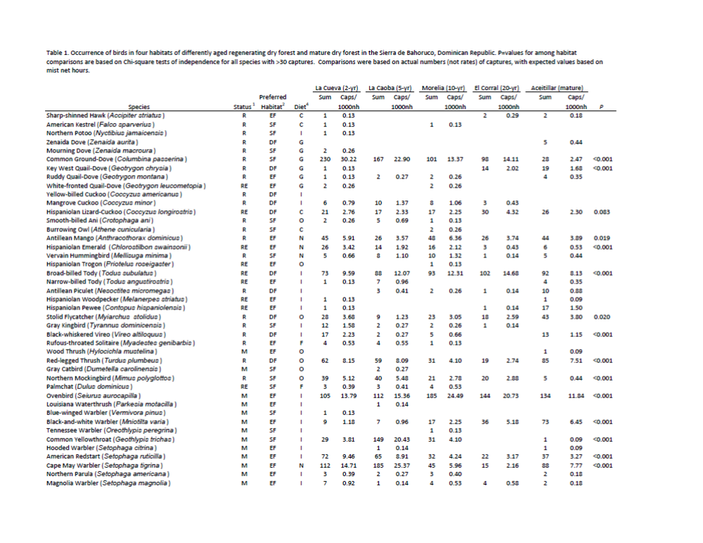
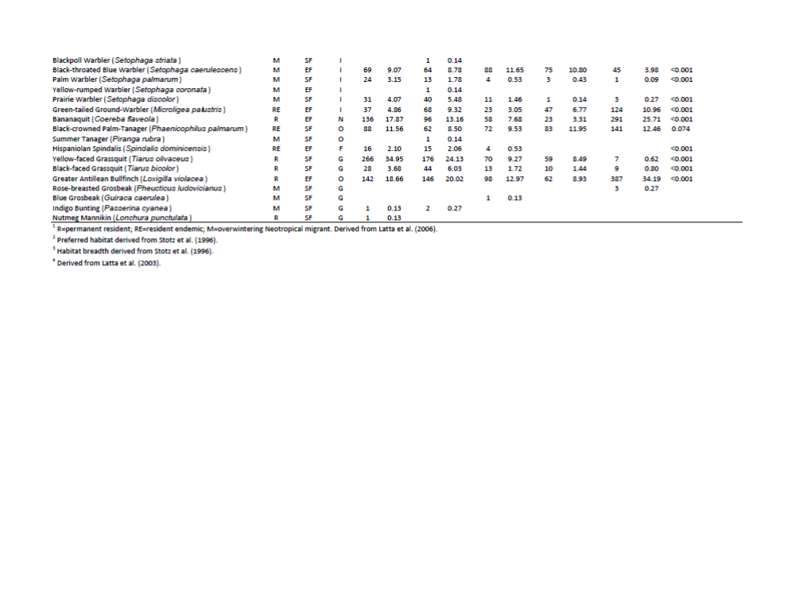

Table 2. Mist-net capture rates, richness, and diversity of birds in regenerating dry forest and mature dry forest in the Sierra de Bahoruco.
 | La Cueva | La Caoba | Morelia | El Corral | Aceitillar
 | 2-yr | 5-yr | 10-yr | 20-yr | mature
Elevation | 395 m | 410 m | 400 m | 400 m | 340 m
Mist net hours | 7612 | 7293 | 7553 | 6946 | 11319
Capture rate¹ | 231.5 | 235.8 | 152.4 | 132.9 | 155.4
Migrant capture rate¹ | 60.8 | 88.7 | 55.9 | 43.2 | 34.5
Resident capture rate¹ | 170.7 | 147.1 | 96.5 | 89.7 | 120.8
Species richness (indivs) | 45 (1762) | 42 (1720) | 40 (1151) | 29 (923) | 37 (1759)
Shannon diversity Index | 2.97 | 2.97 | 2.96 | 2.77 | 2.66
Effective number of species | 19.5 | 19.5 | 19.3 | 16.0 | 14.3
Chao 1 Estimator (SD) | 65.2 (12.6) | 45 (2.7) | 43.6 (3.2) | 41.5 (11.6) | 41.2 (4.0)
Chao 1 confidence interval | 40.4 - 90.0 | 39.6 - 50.4 | 37.2 - 50.0 | 18.8 - 64.2 | 33.3 - 49.0
Evenness | 0.78 | 0.79 | 0.80 | 0.82 | 0.74
Resident spp (indivs) | 33 (1299) | 25 (1073) | 28 (729) | 21 (623) | 24 (1368)
% resident individuals | 73.7% | 62.4% | 63.3% | 67.5% | 77.8%
Endemic spp (indivs) | 11 (269) | 9 (277) | 10 (234) | 7 (267) | 9 (421)
% endemic individuals | 15.3% | 16.1% | 20.3% | 28.9% | 23.9%
Migrant spp (indivs) | 12 (463) | 17 (647) | 12 (422) | 8 (300) | 13 (391)
% migrant individuals | 26.3% | 37.6% | 36.7% | 32.5% | 22.2%
¹ birds captured/1000 mnh
Table 3: Dominance of 5 most abundant species in regenerating dry forest and mature dry forest. Scientific names of species are found in Table 2.

Species | La Cueva | La Caoba | Morelia | El Corral | Aceitillar
 | 2-yr | 5-yr | 10-yr | 20-yr | mature
Common Ground-Dove | 2 (13.0) | 3 (9.7) | 2 (8.8) | 3 (10.6)
Broad-billed Tody |  |  | 4 (8.1) | 2 (11.0)
Ovenbird |  |  | 1 (16.1) | 1 (15.6) | 4 (7.6)
Common Yellowthroat |  | 4 (8.7)
Cape May Warbler | 5 (6.4) | 1 (10.8)
Black-throated Blue Warbler |  |  | 5 (7.6)
Green-tailed Ground-Tanager |  |  |  |  | 5 (7.0)
Bananaquit | 4 (7.7) |  |  |  | 2 (16.5)
Black-crowned Palm-Tanager |  |  |  | 4 (9.0) | 3 (8.0)
Yellow-faced Grassquit | 1 (15.1) | 2 (10.2)
Greater Antillean Bullfinch | 3 (8.1) | 5 (8.5) | 3 (8.5) | 5 (6.7) | 1 (22.0)

Table 4. Similarity indices of birds captured in 5 habitats based on species presence/absence (Jaccard Similarity; unshaded portion), and proportional abundances of individuals mistnetted (Sorenson Index; shaded portion).

 | Cueva | Caoba | Morelia | Corral | Aceitillar
Cueva | -- | 0.81 | 0.69 | 0.59 | 0.57
Caoba | 0.63 | -- | 0.68 | 0.58 | 0.54
Morelia | 0.70 | 0.71 | -- | 0.80 | 0.55
Corral | 0.61 | 0.58 | 0.57 | -- | 0.54
Aceitillar | 0.64 | 0.61 | 0.57 | 0.69 | --

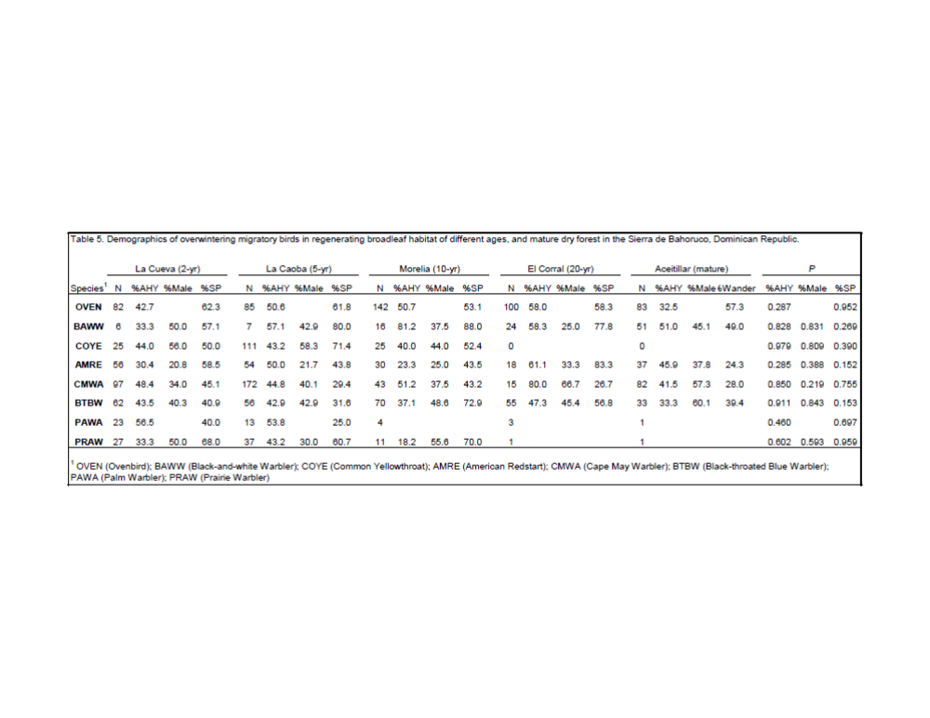
Table 6. Percentage of captured individuals (n) of ten resident species that were site persistent in regenerating pastures and mature dry forest in the Sierra de Bahoruco, Dominican Republic. Scientific names of species are found in Table 2.
 |  | La Cueva | La Caoba | Morelia | El Corral | Aceitillar
Species | Bands¹ | 2-yr | 5-yr | 10-yr | 20-yr | mature | P
Hispaniolan Lizard-Cuckoo |  | 50.0 (10) | 40.0 (10) | 15.4 (13) | 20.0 (20) | 11.1 (10) | 0.253
Stolid Flycatcher | CB | 55.6 (18) | 66.7 (10) | 38.1 (21) | 43.8 (16) | 35.0 (40) | 0.982
Red-legged Thrush |  | 21.4 (42) | 9.7 (41) | 16.7 (18) | 13.3 (15) | 8.3 (60) | 0.358
Northern Mockingbird | CB | 33.3 (24) | 41.9 (31) | 11.1 (18) | 6.3 (16) |  | 0.02
Green-tailed Ground-Tanager | CB | 64.3 (28) | 67.6 (37) | 69.2 (13) | 80.0 (30) | 58.4 (77) | 0.325
Bananaquit |  | 12.4 (113) | 7.8 (77) | 8.3 (48) | 13.6 (22) | 7.2 (97) | 0.653
Black-crowned Palm-Tanager | CB | 57.4 (54) | 47.4 (38) | 56.8 (44) | 70.2 (47) | 33.9 (121) | <0.001
Yellow-faced Grassquit |  | 27.3 (150) | 21.6 (97) | 3.5 (57) | 11.5 (52) |  | <0.001
Black-faced Grassquit |  | 8.3 (24) | 21.2 (33) | 0.0 (13) |  |  | 0.11
Greater Antillean Bullfinch |  | 43.2 (74) | 37.8 (82) | 33.3 (67) | 18.6 (43) | 14.4 (332) | <0.001

¹ Site persistence determined by mist net recaptures, and resighting of those specuies which were uniquely color-banded (CB).
FIGURE CAPTIONS
Figure 1. Estimated species richness in regenerating dry forest with plots representing 2-yr old growth at La Cueva, 5-yr old growth at La Caoba, 10-yr old growth at Morelia, 20-yr old growth at El Corral, and mature dry forest. Analyses of Chao 1 indicators of diversity indicate no significant difference in richness among the sites.
Figure 2. Proportions of individuals captured in mist nets categorized by (a) diet, and (b) preferred habitat type. Captures took place in dry forest regenerating after agricultural clearance with plots representing 2-yr old growth at La Cueva (1,762 birds), 5-yr old growth at La Caoba (1,720 birds), 10-yr old growth at Morelia (1,151 birds), 20-yr old growth at El Corral (923 birds), and mature dry forest (1,759 birds).
Figure 3. Proportions of insect groups (with sample size) captured or observed in (a) sticky traps, and (b) leaf litter samples in dry forest regenerating after agricultural clearance with plots representing 2-yr old growth at La Cueva, 5-yr old growth at La Caoba, 10-yr old growth at Morelia, 20-yr old growth at El Corral, and mature dry forest.
Figure 4. Body condition index (bird mass/wing chord [x100]) of birds (with sample size) captured in dry forest regenerating after agricultural clearance with plots representing 2-yr old growth at La Cueva, 5-yr old growth at La Caoba, 10-yr old growth at Morelia, 20-yr old growth at El Corral, and mature dry forest.
Figure 1.

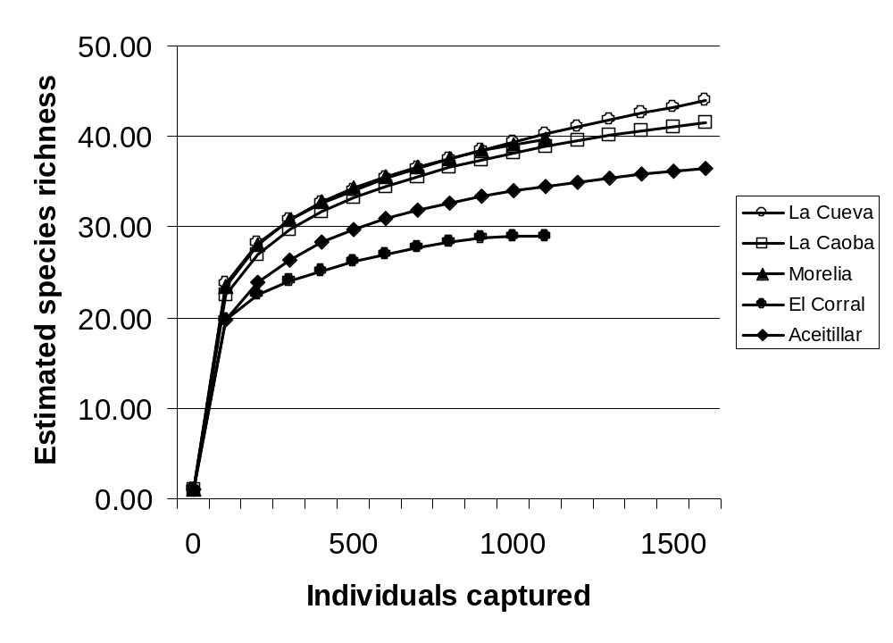
Figure 2.

(a)
La Cueva La Caoba Morelia El Corral Aceitillar

(b)
La Cueva La Caoba Morelia El Corral Aceitillar

Figure 3.

(a)
(323) (348) (599) (399) (749)
La Cueva La Caoba Morelia El Corral Aceitillar

(b)
(210) (227) (213) (294) (112)

La Cueva La Caoba Morelia El Corral Aceitillar

Figure 4.
- Bananaquit
(47)
(110)
(75)
(22)
(71)

- Black-crowned Palm-Tanager
(110)
(37)
(51)
(40)
(45)
- Greater Antillean Bullfinch (male)
(21)
(25)
(43)
(32)
(96)
- Greater Antillean Bullfinch (female)
(22)
(25)
(17)
(15)
(90)
- Green-tailed Ground-Tanager
(28) 
(36)
(13)
(28)
(77)

